The .dot file consists of the decision tree classifier details , with various branches and the leaf nodes. Since there was some issue in converting the .dot file in spyder IDE.

Check the link <http://webgraphviz.com/>:

Open the tree1.dot file from the saved location , which is the below path for me :

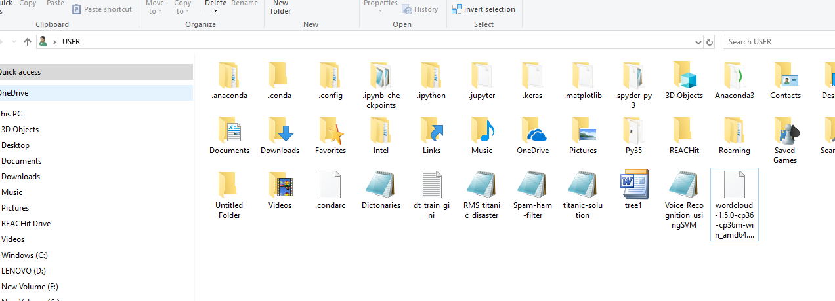

Next , open the content of tree1,dot file in a notepad++

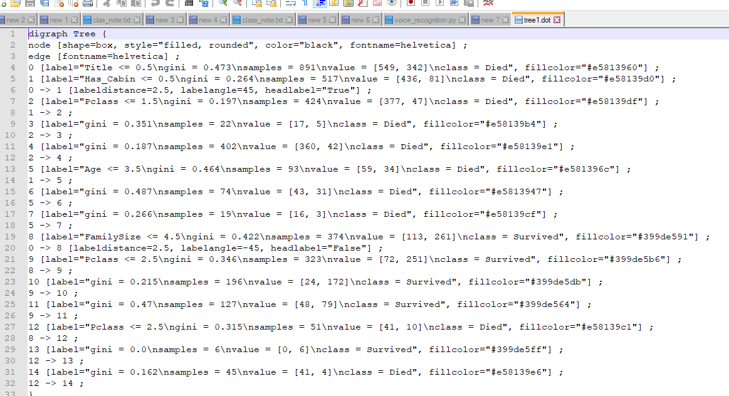

Copy and paste in the URL

<http://webgraphviz.com/>, Then click on Generate Graph ,

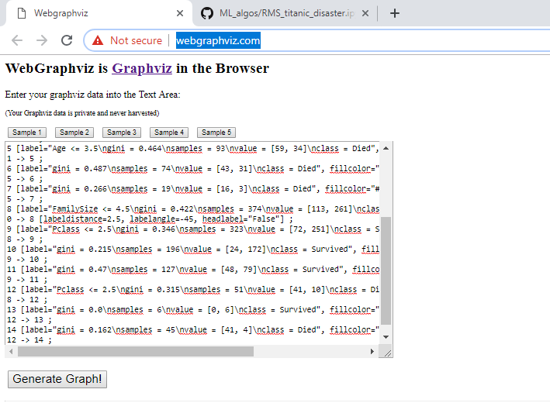

Which gives us the following Tree

